**UNDERGRADUATE CONSERVATION CAREER TRAINING INTERNSHIP**

*This project was funded by grants awarded from the Glenn W. Bailey Foundation and Conservancy Friends of Aquarina.*

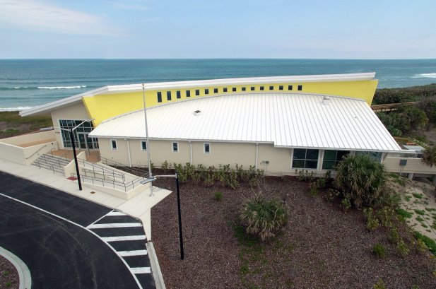**Scope of Internship:** The Barrier Island Center seeks motivated college interns with multi-disciplinary interests to explore careers in environmental education and nature conservation through assisting staff in teaching a Sea Turtle TECH (Technology Education Challenges Horizons) STEM (Science, Technology, Engineering, Math) Mentorship Program for under-served youth, assisting with night turtle walk and daytime nest dig programs, conducting ecological research/trail maintenance, maintaining display aquaria, assisting with gift shop financial reports and operations and receiving mentorship from environmental education and conservation professionals. Interns must be able to work professionally, independently and exhibit a positive attitude at all times, and mentor younger students.

**About the BIC, STC, EELS:** The Barrier Island Sanctuary Management and Education Center (Barrier Island Center) is an educational center located in the heart of the Archie Carr National Wildlife Refuge, a major nesting site for sea turtles in Melbourne Beach, Florida. Through a partnership with the Brevard County Environmentally Endangered Lands Program (EEL), the Sea Turtle Conservancy (STC) manages and conducts summer educational programs offered at the Barrier Island Center.

In North America, sea turtles primarily nest from North Carolina through Florida, with over 90% occurring in Florida. Within that range is the Carr Refuge, a 20.5-mile section of shoreline between Melbourne Beach and Wabasso, along Florida’s east central coast. Since its establishment by Congress in 1989, the Carr Refuge, named after STC’s founding scientific director, has been a major success. The stretch of beach within the Refuge boundary is home to the most important sea turtle nesting habitat in the United States. More loggerheads nest within the Carr Refuge than anywhere else in the Western Hemisphere. In addition, over the past several years there has been a significant increase in green turtle nesting. Protection of these beaches is essential to the survival and recovery of these species

The Barrier Island Sanctuary also has beautiful hiking trails through coastal dunes, maritime hammock and mangrove swamp ecosystems and access to the biodiverse Indian River Lagoon, an estuary of national significance. The Barrier Island Center is a focal point for the Carr Refuge and the associated barrier island by providing exhibit space, a presentation hall, and ongoing educational programs that promote stewardship of the area’s fragile natural resources. The Barrier Island Center hosts visiting school groups from throughout Brevard County, as well as local residents and tourists. The facility, gift shop and exhibits are open to the public. In its 17th year, the BIC serves on- and off-site over 30,000 children and adults through school excursion, camp, lectures, adult education, festivals, and numerous partnerships.

**Eligibility:** The internship is open to undergraduate students and recent graduates, registered at least part-time at their institution of study for the semesters before the summer, who have completed at least one year of coursework at the start of the internship, and who are working towards a four-year degree. Applicants must be in good academic standing, be at least 18 years old, have a valid driver’s license, be eligible for employment in the United States, and be able to lift 50 lbs.

**Commitment: Thursday, May 29th through Thursday, July 31st, 2025. Mandatory intern training begins May 29th at 8 pm for turtle scout training. Paid internship begins June 2nd through July 31st. Work schedule varies depending on program needs. Most weeks the commitment is Monday-Friday, 40-hours per week. Some half day, night and weekend hours will be required. July 26th and 27th are mandatory for our Tour de Turtles releases.**

**Compensation:** This is a paid internship for $13.00 per hour.

**Housing:** Interns are responsible for their own local housing and transportation.

**Application Deadline: April 1st, 2025.**

**UNDERGRADUATE CONSERVATION CAREER TRAINING INTERNSHIP**

2025 APPLICATION

**Application Procedure: Complete the application form and email it along with supporting documentation (see application components below) to Sarah Rhodes-Ondi, STC Community Stewardship Coordinator, at** sarah@conserveturtles.org**.** Contact Sarah via email with any questions.

**To apply, please submit the following:**

1. Completed Application Form.
2. Transcripts showing completion of at least one year of college.
3. Essay, up to two pages in length, describing your career, education and research interests and how the internship will help in discerning and pursuing these.
4. Two letters of recommendation from professionals who can speak to your academic and career goals and ability to pursue them. Please send one from a faculty member at your institution of study (No relatives please).
5. Resume or curriculum vitae.

**Application Form:**

Name: ______________________________________________________________________________________

*Last First Middle*

Address: ____________________________________________________________________________________

*Number Street City State Zip*

Telephone: _____________________________ Date of Birth: ___________________________________

*Area Code and Number*

Email: ______________________________________________________________________________________

Mailing Address:

___________________________________________________________________________________________

*Number Street City State Zip*

Have you ever been employed by BIC? 🞏 Yes 🞏 No If yes, date: ________________________

Are you legally eligible for employment in the United States? 🞏Yes 🞏 No

High School Name and Location: _________________________________________________________________

College/University Name and Location: ___________________________________________________________

Major(s): ________________________________________Minor (if applicable): _________________________

Undergraduate years completed at start of internship: 1 2 3 4 5+

Do you qualify for need based financial aid at your institution of study? Yes______ No_______

Anticipated Graduation Date: ___________________

1. Rank your interest level (1-4, with 1 = most and 5 = least interested) in building the following skills:

_____Assisting with teaching environmental education programs (1st-8th graders)

_____Practicing interpretive skills (greeter at the welcome desk, or serving as docent in exhibit space)

_____Learning ecological field techniques/trail maintenance

_____Learning display aquarist techniques

_____Learning gift shop financial reports and operations

*Please be aware that this is a multi-disciplinary internship and will involve work in all of the above areas.*

1. What do you hope to gain from completing an internship at the Barrier Island Center?
2. Please describe any prior research experience. We are especially interested in your experience in outdoor field work.
3. If interested in a research career, what subject areas would you most like to research in the future?
4. Please describe any prior experience working with, teaching or mentoring younger children.
5. Are you willing to be paired with a high school student intern to work as a near peer mentor on a team independent project? 🞏 Yes 🞏No
6. Please share any special experiences, honors, awards, clubs, or extracurricular activities that are relevant to this internship.
7. **Essay:** Please share your career interests and goals and explain how an internship at the Barrier Island Center will help discern your academic and career path? (Attach two pages maximum, please)

By my signature below I certify that all information in this application is accurate to the best of my knowledge. I authorize the Barrier Island Center to seek verification as needed during the selection process.

_______________________________ _________________________

Signature Date